Weather:  Hurricane  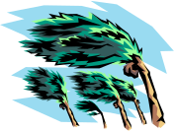  One enemy ship in the Atlantic is lost.  Play Immediately | Weather:  Hurricane  One enemy ship in the Atlantic is lost.  Play Immediately | Weather:  Hurricane  One enemy ship in the Atlantic is lost. | Weather:  Typhoon  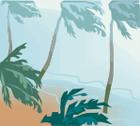  One enemy ship in the Pacific is lost.  Play Immediately | Weather:  Typhoon  One enemy ship in the Pacific is lost.  Play Immediately
Weather:  Typhoon  One enemy ship in the Pacific is lost. | Weather:  Typhoon  Two enemy ships in the Pacific is lost.  Play Immediately | Weather:  Rough Seas: Europe  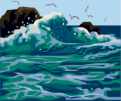  Amphibious landings forbidden for one turn.  Play Immediately | Weather:  Rough Seas: Europe  Amphibious landings forbidden for one turn.  Play Immediately | Weather:  Rough Seas: Pacific  Amphibious landings forbidden for one turn.  Play Immediately
Weather:  Cloud Cover: Europe  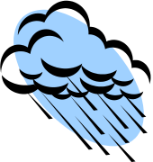  One turn aircraft are grounded in one territory.  Play Immediately | Weather:  Cloud Cover: Europe  One turn aircraft are grounded in one territory.  Play Immediately | Weather:  Cloud Cover: Europe  One turn aircraft are grounded in one territory. | Weather:  Cloud Cover: Pacific  One turn aircraft are grounded in one territory.  Play Immediately | Weather:  Cloud Cover: Pacific  One turn aircraft are grounded in one territory.  Play Immediately
Weather:  Cloud Cover: Pacific  One turn aircraft are grounded in one territory. | Weather:  Earthquake    IPCs reduced by half from one territory for one turn.  Play Immediately | Weather:  Fire  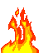  Factory may not produce for one turn.  Play Immediately | Weather:  Fire  Factory may not produce for one turn.  Play Immediately | Weather:  Fire  IPCs for one territory reduced by half for one turn.  Play Immediately
Weather:  Winter Weather: Russia  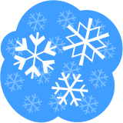  Movement and combat rolls -1  Play Immediately | Weather:  Winter Weather: Russia  Movement and combat rolls -1  Play Immediately | Weather:  Winter Weather: Europe  Movement and combat rolls -1  Play Immediately | Weather:  Winter Weather: Europe  Movement and combat rolls -1  Play Immediately | Weather:  Winter Weather: Northern Asia  Movement and combat rolls -1  Play Immediately

Political:  Alliance    Neutral joins you.  1 Infantry  1 Armor  Play Immediately | Political:  Alliance  Neutral joins you.  2 Infantry  1 Armor  Play Immediately | Political:  Investment    3 Neutrals invest their IPCs for one turn in your economy. | Political:  Investment  3 Neutrals invest their IPCs for one turn in your economy. | Political:  Transit Rights  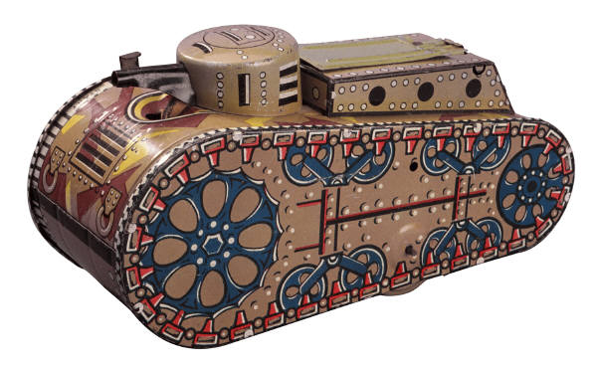  Military units may pass through one neutral country.
Political:  Transit Rights  Military units may pass through one neutral country.  Play Immediately | Political:  Disenchantment  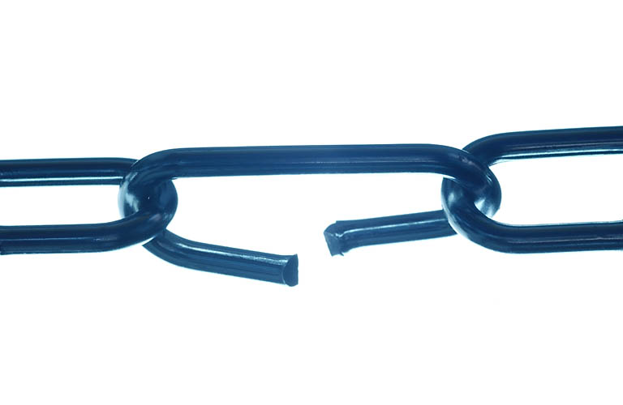  One territory (not a home territory) goes neutral.  Play Immediately | Political:  Disenchantment  One territory (not a home territory) goes neutral.  Play Immediately | Political:  Moral Boost    Infantry costs one less for one turn. | Political:  Moral Boost  Infantry costs one less for one turn.
Political:  Oil Crunch    All units (except infantry) movement is reduced by one for one turn.  Play Immediately | Political:  Oil Crunch  All units (except infantry) movement is reduced by one for one turn.  Play Immediately | Political:  Oil Crunch  All units (except infantry) movement is reduced by one for one turn.  Play Immediately | Political:  Oil Crunch  All units (except infantry) movement is reduced by one for one turn.  Play Immediately | Political:  Oil Crunch  All units (except infantry) movement is reduced by two for one turn.  Play Immediately
Political:  Disenfranchised    Infantry costs one more for one turn.  Play Immediately | Political:  Disenfranchised  Infantry costs one more for one turn.  Play Immediately | Political:  Shortage    All units except infantry cost one more for one turn.  Play Immediately | Political:  Shortage  All units except infantry cost one more for one turn.  Play Immediately | Political:  Rally  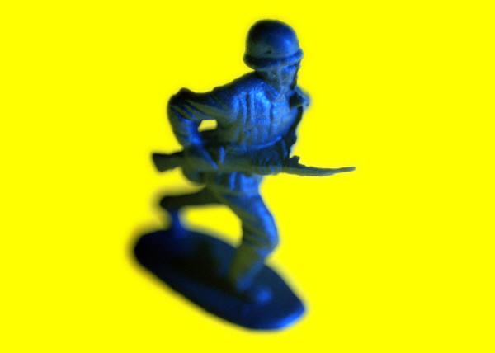  Volunteers from one neutral attack across their border for you. Two Infantry.
Technology:  Achievement    Add one to a die for a technology roll. | Technology:  Achievement  Add one to a die for a technology roll. | Technology:  Achievement  Add one to a die for a technology roll. | Technology:  Capture    Add two to a die for a technology roll in which one player already has acquired that technology. | Technology:  Capture  Add two to a die for a technology roll in which one player already has acquired that technology.

Technology:  Sabotage    Reduce one to a die for a technology roll. | Technology:  Sabotage  Reduce one to a die for a technology roll. | Technology:  Failure  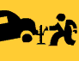  For one turn technology fails. | Technology:  Failure  For one turn technology fails. | Technology:  Breakthrough    Gain one technology  Play Immediately
Resistance:  Road Closure    One unit’s movement is reduced by one for one turn. | Resistance:  Road Closure  One unit’s movement is reduced by one for one turn. | Resistance:  Road Closure  One unit’s movement is reduced by one for one turn. | Resistance:  Road Closure  One unit’s movement is reduced by two for one turn. | Resistance:  Factory Strike  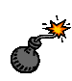  Factory may not produce units for one turn.  Play Immediately
Resistance:  Factory Strike  Factory may not produce units for one turn. | Resistance:  Sabotage  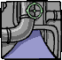  Roll one die. 1-2 specified unit is destroyed.  Play Immediately | Counter:  Weather    The Weather turns fair. | Counter:  Political    You manage to politically nullify the enemy. | Counter:  Resistance    You catch and halt a resistance attempt.
Leader:  Land    Once per turn in a land battle all units in territory gain +1. | Leader:  Land  Once per turn in a land battle all units in territory gain +1. | Leader:  Air  Once per turn in a air battle all units in territory gain +1. | Leader:  Air  Once per turn in a air battle all units in territory gain +1. | Leader:  Sea  Once per turn in a sea battle all units in territory gain +1.
Leader:  Sea  Once per turn in a sea battle all units in territory gain +1. | Leader:  Eliminated  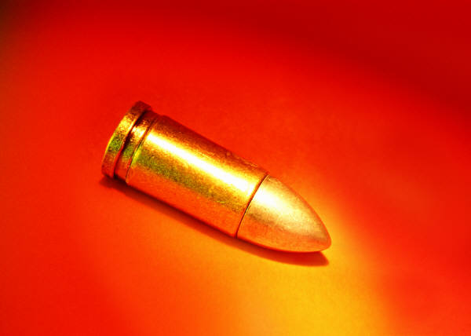  In a battle a leader is eliminated at its conclusion. | Leader:  Eliminated  In a battle a leader is eliminated at its conclusion. | Leader:  Eliminated  In a battle a leader is eliminated at its conclusion. | Leader:  Eliminated  In a battle a leader is eliminated at its conclusion.

Leader:  Eliminated  In a battle a leader is eliminated at its conclusion. | Leader:  Eliminated  In a battle a leader is eliminated at its conclusion. | Leader:  Assassinated  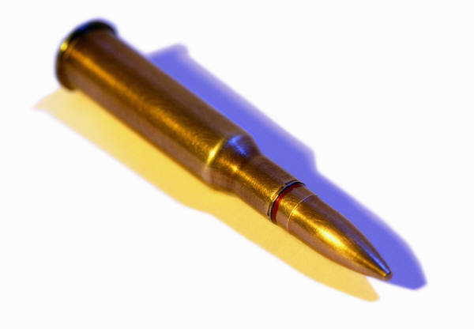  A leader is assassinated. | Leader:  Assassinated  A leader is assassinated. | Leader:  Assassinated  A leader is assassinated.
Training:    For one turn one type of unit in one territory receives +1 for combat. | Training:  For one turn one type of unit in one territory receives +1 for combat. | Training:  For one turn one type of unit in one territory receives +1 for combat. | Training:  For one turn one type of unit in one territory receives +1 for combat. | Training:  For one turn one type of unit in one territory receives +1 for combat.
Surpise Attack:    Defenders receive -1 to their first round of combat. | Surpise Attack:  Defenders receive -1 to their first round of combat. | Surpise Attack:  Defenders receive -1 to their first round of combat. | Surpise Attack:  Defenders receive -1 to their first round of combat. | Surpise Attack:  Defenders receive -1 to their first round of combat.
Elite Training    Once per turn one type of unit receives +1 to combat. | Elite Training  Once per turn one type of unit receives +1 to combat | Elite Training  Once per turn one type of unit receives +1 to combat | Elite Training  Once per turn one type of unit receives +1 to combat | Elite Training  Once per turn one type of unit receives +1 to combat
Stout Defense:  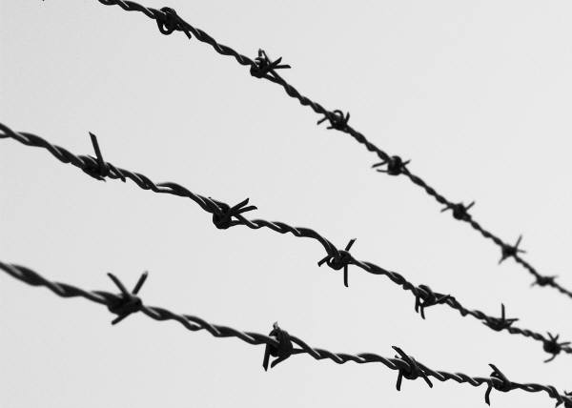  Defending units in a territory receive +1 to defense per turn. | Stout Defense:  Defending units in a territory receive +1 to defense per turn.. | Stout Defense:  Defending units in a territory receive +1 to defense per turn.. | Stout Defense:  Defending units in a territory receive +1 to defense per turn.. | Stout Defense:  Defending units in a territory receive +1 to defense per turn..

